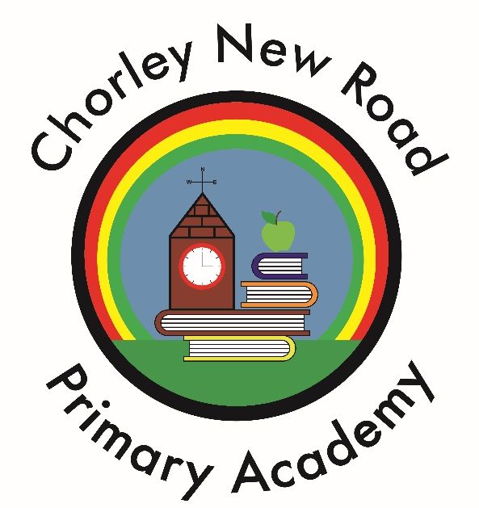
Challenge, Nurture, Respect

SCHOOL UNIFORM POLICY

Ratified by Governors: September 2022

Reviewed Annually:

Reviewed: September 2023

Chair of Governors: _______________________________ Date: _______________

Head Teacher: __________________________________ Date: _______________

School Uniform Policy

1 Rationale

Our policy on school uniform is based on the notion that school uniform:
- promotes a sense of pride in the school;
- engenders a sense of community and belonging towards the school;
- is practical and smart;
- identifies the children with the school;
- prevents children from coming to school in fashion clothes that could be distracting in class;
- makes children feel equal to their peers in terms of appearance;
- is regarded as suitable wear for school and good value for money by most parents;

2 Guidelines

Uniform colours | Uniform
Black | Shorts/long trousers  Skirt, pinafore dress  One or the other is required
Royal Blue | V neck, crew neck, sweatshirt, cardigan or jumper  required  (LOGO OPTIONAL)
White | Polo shirt (logo optional) required
Blue checked | Summer dress (Summer Term only) optional
Black | Shoes (not trainers) required
Grey or Black | Tights or socks required
P.E
Royal Blue | Shorts required
White | T-Shirt (LOGO OPTIONAL) required
Plimsolls (Indoor) | Black required
Trainers (Outdoor) | Non specific required
Royal Blue | Hoodie (logo optional) optional
Royal Blue or Black | Joggers optional

Sweatshirts/Cardigans with school logo and P.E. T-shirts and Shorts are for sale at Andrew Leach’s, Lee Lane, Horwich and Whittakers Schoolwear, Deansgate, Bolton

All other items can be bought from a variety of retail outlets.

School uniform must not be embroidered on the front with child’s name.

All children require a pair of plimsolls (preferably with an elasticised top).

All items of clothing, including footwear, should be labelled. This ensures that lost items can easily be identified

Please reduce the “risks” by ensuring that every garment or piece of footwear bears your child’s name

3 Jewellery

On health and safety grounds children may not wear jewellery in our school. The exceptions to this rule are watches, but these must be kept to a low value and appropriate size. We ask the children to remove them during PE, games and swimming to prevent them from causing injury. Earrings are not to be worn in school.

4 Footwear

Children should wear black shoes as part of their uniform for health and safety reasons.

5 Hair Styles

Children should not have extreme hair styles which draw attention to
themselves e.g. including eye brows, tram lines, Mohican, shaving.
Hair colour should be one matching natural shade. No creative block colour or contrasting colours are allowed.

6 Other requirements

Make up and nail varnish are not allowed.

7 Non Uniform Days

On non- uniform days pupils have the opportunity to wear their own clothes but there is a clear expectation that they dress appropriately for school taking into account health and safety and the weather at the time. The additional requirements of the uniform policy on hair styles, jewellery, make up and nail varnish will still apply.

8. The role of parents

8.1 We ask all parents who send their children to our school to support the school uniform policy, by ensuring that their children wear the appropriate clothing and footwear.

8.2 If any parent would like the school to modify the uniform policy, they
should make representation, in the first instance, to the headteacher. The school welcomes children from all backgrounds and faith communities. If there are serious reasons, for example on religious grounds, why parents want their child to wear clothes that differ from the school uniform, the school will consider such requests.

9 Conclusion

It is our aim that all children wear school uniform when attending school, or when participating in a school-organised event outside normal school hours should this be appropriate. We provide a list of the items needed for school uniform in our school prospectus
The Headteacher’s decision is final.

