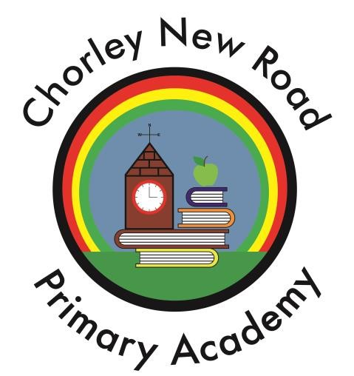

Challenge, Nurture, Respect

SPECIAL EDUCATIONAL NEEDS POLICY

Date: September 2023

Special Education Needs Policy and Local Offer

AIMS

Our SEN policy and information report aims to:
- Set out how our school will support and make provision for pupils with special educational needs (SEN)
- Explain the roles and responsibilities of everyone involved in providing for pupils with SEN
Chorley New Road Primary Academy aims to enable pupils with special education needs and disabilities to be fully involved in the life of the school and to reach their full potential. We want all children to take an active role in school life, feeling secure and happy whilst experiencing success in a caring and stimulating learning environment. The school also aims to involve pupils, their parents, staff and other concerned parties in the development of the necessary support for each child with special educational needs.

Legislation and guidance
This policy and information report is based on the statutory Special Educational Needs and Disability (SEND) Code of Practice and the following legislation:
- Part 3 of the Children and Families Act 2014, which sets out schools’ responsibilities for pupils with SEN and disabilities
- The Special Educational Needs and Disability Regulations 2014, which set out schools’ responsibilities for education, health and care (EHC) plans, SEN co-ordinators (SENCOs) and the SEN information report
- Consideration is also taken of the Single Equality Act 2010

DEFINITION OF SPECIAL EDUCATIONAL NEEDS

A child or young person has SEN if they have a learning difficulty or disability which calls for special educational provision to be made for them.

A child of compulsory school age or a young person has a learning difficulty or disability if they:

- have a significantly greater difficulty in learning than the majority of others of the same age; or
- have a disability which prevents or hinders them from making use of educational facilities of a kind generally provided for others of the same age in mainstream schools.
- A child under compulsory school age has special educational needs if they fall within the definition at (a) or (b) above or would so do if special educational provision was not made for them(Clause 20 Children and Families Bill)

This is a broad definition covering children and young people from 0- 25 years of age. Where a child or young person has a disability or health condition which requires special educational provision to be made, they will be covered by the SEN definition.

OBJECTIVES

- To create an inclusive environment that meets the special educational needs of each child;
- To ensure that the special educational needs of children are identified, addressed and provided
for;
- To make clear the expectations of all partners in the process (including parents and children);
To ensure children become confident individuals living fulfilling lives and achieving their best
- To identify the roles and responsibilities of staff in providing for children’s educational needs;
- To enable all children to have full access to all elements of the school curriculum;
- To actively involve pupils in a sensitive and non-stigmatising way in the planning process to promote improved confidence and self-image.

ROLES AND RESPONSIBILITIES

The role of the Headteacher

The Headteacher is: Miss Burrows

At Chorley New Road the Headteacher will:
- Work with the SENCO and SEN Trustee to determine the strategic development of the SEN policy and provision in the school
- Have overall responsibility for the provision and progress of learners with SEN and/or a disability

The role of the SENCO.

The SENCO is Mrs A Ashton-Ross
At Chorley New Road the SENCO will:

- Work with the Headteacher and SEN Trustee to determine the strategic development of the SEN policy and provision in the school.
- Have day-to-day responsibility for the operation of this SEN policy and the co-ordination of specific provision made to support individual pupils with SEN, including those who have EHC plans.
- Provide professional guidance to colleagues and work with staff, parents, and other agencies to ensure that pupils with SEN receive appropriate support and high quality teaching
- Managing Teaching Assistants;
- Advise on the graduated approach to providing SEN support.
- Advise on the deployment of the school’s delegated budget and other resources to meet pupils’ needs effectively.
- Be the point of contact for external agencies, especially the local authority and its support services.
- Liaise with potential next providers of education to ensure pupils and their parents are informed about options and a smooth transition is planned.
- Work with the Headteacher and trust board to ensure that the school meets its responsibilities under the Equality Act 2010 with regard to reasonable adjustments and access arrangements.
- Ensure the school keeps the records of all pupils with SEN up to date
- Liaising with the dedicated teacher in early years, the early years lead for early identification and needs analysis

The role of the Trustees

The SEN Trustee is Helen Brown

At Chorley New Road the SEN Trustee will:
- Help to raise awareness of SEN issues at trust board meetings
- Monitor the quality and effectiveness of SEN and disability provision within the school and update the trust board on this
- Work with the Headteacher and SENCO to determine the strategic development of the SEN policy and provision in the school

The Role of class teachers
At Chorley New Road the class teachers will:

- be responsible for the progress and development of every pupil in their class providing support and challenge.
- ensure planning is fully inclusive and that support staff have copies of planning in advance
- implement in-class support and differentiate the teaching the National Curriculum.
- work closely with any teaching assistants or specialist staff to plan and assess the impact of support and interventions and how they can be linked to classroom teaching.
- be fully aware of the school’s procedures for identifying, assessing and making provision for pupils with Special Educational Needs, including writing personalised plans and reviewing and reporting progress to parents/carers.
- work with the SENCO to review each pupil’s progress and development and decide on any changes to provision.
- meet termly with the assessment coordinator and Headteacher to monitor the progress of vulnerable pupils and act upon their findings to ‘close the gap‛ in learning.
- be involved with consultation and planning with parents and SENCO and attend review meetings
- where appropriate, share with the individual their learning targets and enable them to participate in decision making regarding their special needs.
- ensure the school SEN policy is followed.

The role non-teaching staff

At Chorley New Road the support staff will:

- be fully aware of the school’s procedures for identifying, assessing and making provision for pupils with Special Educational Needs
- work with the SENCO to review each pupil’s progress and development and offer suggestions to changes in provision
- to provide appropriate and challenging activities for pupils with Special Educational Needs
- implement interventions, monitor their impact and feedback to the class teacher
- work with groups and individuals to help them become independent learners
- attend review meetings when necessary

ADMISSION ARRANGEMENTS

Chorley New Road Primary Academy, acknowledges its statutory duty to provide a mainstream school place for all pupils, regardless of their gender, ethnicity, religion, disability or special educational need, should their parents wish it and it is compatible with the efficient education of other pupils.

We recognise the intrinsic value of every child, and we aim to meet all children’s needs. (Schedule 1 paragraph 4)

ACCESS TO THE CURRICULUM, INCLUDING THE NATIONAL CURRICULUM

All pupils follow the full National Curriculum except where disapplication is clearly indicated, and this decision is fully supported by the Local Authority. All SEN pupils including those with an Education and Health Care Plan (EHCP) spend the majority of their time in mainstream classes following the same curriculum as their peers, adapted where necessary. Pupils who need it are withdrawn for short periods for individual programmes based upon their personalised plans. Care is taken not to disadvantage pupils by this withdrawal. Staff give consideration to children with Special Educational Needs within their short term planning, and work is differentiated so that it is accessible to all children. This can be evidenced from planning and artefacts produced by the children.

INCLUSION ARRANGEMENTS FOR PUPILS WITH S.E.N.

All pupils play a full part in the life of the school. They have entitlement to all curricular and extracurricular activities carried out at school. Those pupils who need individual tuition are withdrawn only for short periods.

FACILITIES

Educational access:
- The school employs a number of Teaching Assistants whose role includes the support of individuals or groups of children who need extra help in order to access the curriculum.
- The Teaching Assistants work closely with the class teachers and use recommendations of the children’s personalised plans, in order to support learning and assist the children in reaching their targets.
- The school also provides Therapeutic Interventions. The Learning Assistant with responsibility for these groups works closely with the head of safeguarding and extended services, and class teachers in identifying and supporting children who will benefit from a range of small group and/or 1:1 interventions.

Allocation of resources:

- The SENCO is responsible for the operational management of the specified and agreed resourcing for special needs provision within the school, including the provision for children with statements of special educational needs.
- The Head Teacher informs the trust board of how the funding allocated to support special educational needs has been employed.
- The Head Teacher and the SENCO meet on a regular basis to agree on how to use funds directly related to S.E.N.
- The SENCO. prepares an audit and action plan for the School Improvement Plan, which is monitored by the Trust Board and Head Teacher

WORKING IN PARTNERSHIP WITH PARENTS

Chorley New Road actively seeks to work with parents to empower them to:
- recognise and fulfil their responsibilities as parents and play an active and valued role in their children’s education;
- have knowledge of their child’s entitlement within the SEN framework;
- make their views known about how their child is educated;
- have access to information, advice and support during assessment and any related decision making processes about special needs provision.
- Ensure they know about the local offer https://www.bolton.gov.uk/sendlocaloffer/
- and our school offer through the information report (available on the website)

To enable this:
- Parents are informed at an early stage of any school concerns about their child.
- Parents are encouraged to visit school and discuss any concerns or problems with the class teacher, head teacher or SENCO.
- Parents are encouraged to be involved in SEN provision they may be part of and to take an active role in developing personalised plans; Pastoral Support Programmes (P.S.P.) and Education Health Care Plans (E.H.C.P.).
- Parents are encouraged to take an active role in the monitoring their child’s progress through regular review meetings.
- Problems and concerns are discussed and resolved through meetings with parent, pupil, class teacher, head teacher, SENCO, outside agencies and parent partnership-if required. The views and wishes of parents play an important part in these discussions and decisions.
- The school will inform parents of the Parent Partnership Services available within the Local authority
- School is aware that some parents will be anxious about their children needing S.E.N. provision, and may find meetings with professional bodies stressful. We strive to make meetings parent friendly and convenient to all concerned.
- Parents have the opportunity to record their views in a section of the review form.

PUPIL PARTICIPATION

Children, who are capable of forming views, have a right to receive and make known information, to express an opinion, and to have that opinion taken into account in any matters affecting them. The views of the child should be given due weight according to the age, maturity and capability of the child (Articles 12 and 13: The United Nations Convention on the Rights of the Child)

To enable this:
- We aim to give children the opportunity to discuss feelings and views with family and staff, and to contribute to the development of their personalised plan at an appropriate level.
- We aim to ensure that children are aware of their targets, if they have achieved them, or of the progress that they have made. Children, if possible, sign their personalised plan with their parents.
- Children celebrate their success through praise from staff, certificates, stickers, rewards, sharing their success with other children and teachers, thus raising self-esteem and their motivation to succeed.
- Children are given the opportunity to discuss concerns and problems, whether they be learning, social, emotional, behavioural or physical. They discuss why the problems occur, ways of avoiding them, how to resolve them and ways forward.
- The purpose of any assessment and personalised plan is explained to the child, to avoid any anxiety or confusion.
- The purpose of any visiting professional is explained to the child.
- School acknowledges the importance of providing therapeutic interventions for children.

FOUNDATION STAGE: ASSESSMENT AND IDENTIFICATION

- Teachers acknowledge that during the Foundation Stage, due to various previous learning and life experiences, also taking into account some children may not have received any Nursery Education when they enter Reception that children will progress at different rates. This may not necessarily mean they are children with S.E.N., but they will need carefully adapted learning experiences and activities to ensure that they make satisfactory progress.
- On entering Nursery, children are monitored using the Foundation Stage Individual Assessment Profile. The EYFS lead is the dedicated Sen early years teacher who will liaise with the SENCO when necessary.

PRIMARY PHASE: ASSESSMENT AND IDENTIFICATION
We will assess each pupil’s current skills and levels of attainment on entry, which will build on previous settings and Key Stages, where appropriate. Class teachers will make regular assessments of progress for all pupils and identify those whose progress:
- Is significantly slower than that of their peers starting from the same baseline
- Fails to match or better the child’s previous rate of progress
- Fails to close the attainment gap between the child and their peers
- Widens the attainment gap
This may include progress in areas other than attainment, for example, social needs.
Slow progress and low attainment will not automatically mean a pupil is recorded as having SEN.
When deciding whether special educational provision is required, we will start with the desired outcomes, including the expected progress and attainment, and the views and the wishes of the pupil and their parents. We will use this to determine the support that is needed and whether we can provide it by adapting our core offer, or whether something different or additional is needed.

GRADUATED RESPONSE

- The school’s response is broken down into four major stages:
- Monitoring through pupil progress meetings- step 1 - Quality first teaching
- Interventions within school –- step 2
- Personalised plan – may involve support from outside agencies –step 3
(Assessments and/or Interventions by other support agencies)
- Statutory Assessment for EHCP –step 4

A child does not automatically progress up the stages. Intervention and stage of need may remain static if the child’s progress is deemed appropriate and they may even move down the process.

• When a teacher is concerned about a child’s progress they will arrange to speak to parents, and the SENCO or Head Teacher if appropriate.

Assess plan, do and review to support the graduated response
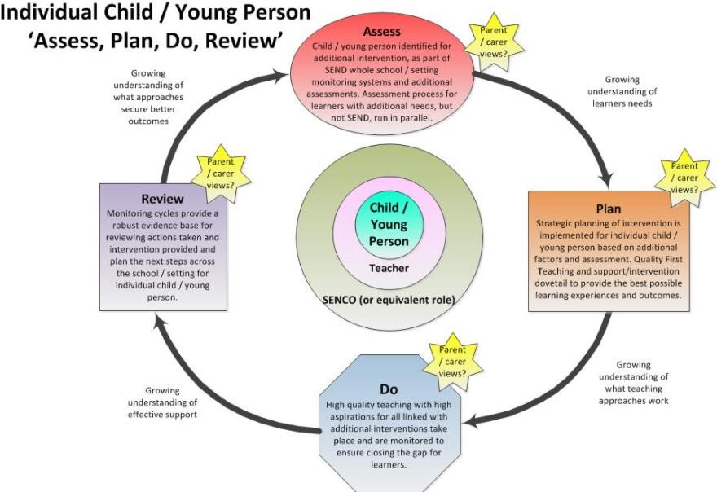

SEN support
‘When a class teacher or other educational practitioner, who works day to day with the child, or the SENCO identifies a child with special educational needs and has already concerned that child, they should devise interventions that are additional to or different from those provided as part of the settings usual curriculum offer and strategies. (Early Years/School Action)

- Teachers, parents and where appropriate, the child, will develop a personalised plan. The SENCO is available for help and advice on strategies and resources. The personalised plan will focus on approximately 2 - 4 targets. The personalised plan will show how the targets will be achieved and the criteria for success.

- After an agreed period of time the personalised plan will be reviewed by staff involved and parents. The child’s progress will be discussed and new targets agreed.
Personalised plans will be reviewed at least termly and, if it is deemed appropriate, more often, if the needs of the child indicated this.

- If it is considered that the child has not made satisfactory progress then the SENCO, or head teacher will seek advice and support from outside agencies.

- A referral may be made to the Educational Psychologist, who will carry out further assessments and give advices. Alternatively a referral may be made to the Behaviour Team or the school nurse. After initial meetings with one or more of these agencies, other specialists may be contacted to deal with the specific needs of individual children. Parents will continually be involved and kept informed of the steps the school is taking.

- The SENCO, head teacher, class teacher, support staff will then use information from the previous personalised plans, plus any additional information from outside agencies to develop a new personalised plan, with new targets.

- The new personalised plan and targets are discussed with the parents and child.

Statutory Assessment for EHCP:

- If, after several personalised plans have been developed, monitored and reviewed, the child has not made satisfactory progress, the school, after discussions with parents (taking into account outside agencies advices and reports) will consider asking the Local Authority for a statutory assessment of the child.
- All reports from outside agencies, personalised plans, reviews and any relevant information are then sent to the Local Authority along with completed forms.
- If the Local Authority decides to proceed with statutory assessment, Educational advices are sent to the school and completed by the SENCO and class teacher and returned as soon as possible.

Annual Reviews (All funded pupils are reviewed every twelve months)

- The SENCO arranges the Annual Review, inviting all the relevant outside agencies, parents and informs the Local Authority of the date, who may send a representative to the meeting.
- At the review meeting the child’s progress is discussed in relation to the objectives listed in the EHCP.
- The current personalised plan is available, and targets and progress discussed.
- The school provision is discussed, such as equipment, resources and staffing, to ensure that the provision is appropriate and continues to meet the needs of the child.
- It is decided whether or not, the EHCP is still appropriate.
- If the EHCP remains in place, new targets may be set for the coming year.

NATURE OF INTERVENTION

The SENCO and the child’s class teacher will decide on the action needed to help the child to progress in the light of the assessment, and if necessary additional advice from outside agencies. This may include:

- different learning materials, or special equipment;
- Some group or individual support; (by Teacher, Teaching Assistant, etc.)
- Extra adult time to devise the nature of the planned intervention and to monitor its effectiveness
- Staff development and training to develop knowledge of problems and to introduce and deliver more effective strategies;
- Access to Local Authority support services for one-off or occasional advice on strategies or equipment.

Personalised plans

Strategies employed to enable a child to progress will be recorded on a personalised plan. Each of these plans will include information about:

- The short term targets or goals set for the child;
- The teaching strategies to be used;
- The provision to be put in place;
- When the plan is to be reviewed;
- Outcomes (to be recorded when the plan is reviewed, or as they are achieved.) •
- Evidence that the parent and, if appropriate, the child have read and understood it.

The individual personalised plans will only record that which is additional to; or different from, the differentiated curriculum and will focus upon three or four individual targets that match the child’s needs and have been discussed with the child and parents. The plans will be reviewed at least twice a year, and parents’ views or their child’s progress will be sought. Wherever possible the child will also take part in the review process and be involved in the setting of new targets.

TRANSITION OF PUPILS

- Meetings are arranged between staff during the summer term to discuss the transfer of children from one class to another within the school. Details of personalised plans are transferred to the new teacher, along with any relevant materials.
- The class SEN file is also passed on to the new class teacher.
- For children transferring between Key Stage Two and Key Stage Three, a meeting is arranged with the appropriate SENCO of the school they are transferring to, to pass information.
- In the event of a supported transfer, either at this point or at any other point in the year, staff will attend the appropriate meeting to support that child’s transfer to a new school, with the child, parents, staff from the new school, and any other involved parties.
- Children, who are funded, have a transition review, to which all involved parties are invited.
(Parents, Local Authority officers, Health staff, Educational Psychologists High school SENCO etc.) If a transfer plan is required, one is recommended and will be in place prior to the child’s arrival in their High school

LINKS WITH OTHER SERVICES

The school has links with the following organisations on a regular basis:

- L.A. Access and Inclusion Service
- Educational Psychology Services
- Speech Therapy Services
- Health Services (School nurse)
- Social Services
- Paediatric services
- Ladywood Outreach Service
- Behaviour Support Team
- Child and Adolescent Mental Health Services
- Children’s Disability Services
- Sensory Service
- Occupational Therapy
- Audiology Service
We seek advice and examples of good practice from:
- The Specialist Schools within Bolton
- Other schools.
- Voluntary agencies linked to specific disorders.

We are always willing to seek advice and help with the aim of achieving the best for each of the pupils in our school.

MONITORING

- The SENCO liaises with outside agencies.
- SENCO meets regularly with the Inclusion Lead, Educational Psychologist and other professionals through the termly planning meeting.
- SENCO meets regularly with head teacher and reports to governing body.
- SENCO meets regularly with head of safeguarding and extended services.
- SENCO meets regularly with each member of staff and monitors their S.E.N. file ensuring targets are measurable and achievable.
- Notes from the meetings/monitoring are copied and given to staff.
- Copies of all plans and reviews are passed to SENCO for central record.
- SENCO attends reviews whenever possible, and always attends reviews of funded children.
- SENCO file contains information on every child at Early Years Action / School Action, Early Years Action Plus / School Action Plus and Statement.
- SENCO attends L.A. SENCO UPDATE meetings.

RESPONSE TO COMPLAINTS

Parents or children who are dissatisfied with any aspect of the special needs support offered should make their complaints:
- In the first instance to the Head teacher.
- If a parent is still unhappy, she/he can put her/his complaint in writing to the Chairperson of the Governing Body.
- Further appeal can be made to the CEO.

LINKS TO OTHER POLICIES

- Safeguarding
- Behaviour
- Gifted and Talented
- Physical Restraint
- Reference in Curriculum Policies.

