THE LESSON
A lesson is a period of learning. Lessons may take any length of time and may be split over several days. To deliver each lesson effectively, teachers need to be expert in preparing before the lesson, teaching during the lesson and reviewing after the lesson. Support for these three elements is the focus of PPD.
1 - Before the lesson
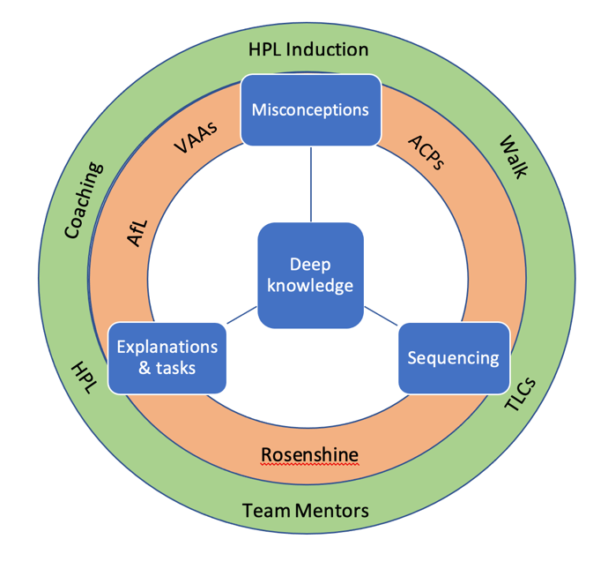
Before the lesson the teacher will ensure they:
- Have deep and fluent knowledge and flexible understanding of the content they are teaching.
- Have knowledge of the requirements of curriculum sequencing and dependencies in relation to the content and ideas they are teaching.
- Have knowledge of relevant curriculum tasks, assessments and activities, their diagnostic and didactic potential; being able to generate varied explanations and multiple representations/analogies/ examples for the ideas they are teaching.
- Have knowledge of common pupil strategies, misconceptions and sticking points in relation to the content they are teaching
Taken from Great Teaching Toolkit

2 - During the lesson
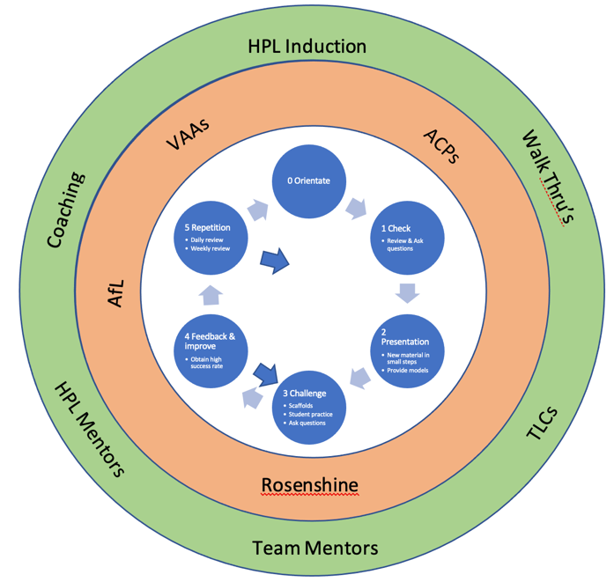
Excellent teachers follow the central cycle above, summarised by the evidence-based teaching network. First, they orientate, then review and present new information. This is followed by the challenge – feedback look and finally repetition. Each of these steps uses principles of instruction identified as valid by Rosenshine.
The teaching cycle will also be underpinned by HPL VAAs and ACPs, the behaviours and thinking skills which are taught to pupils so they become high performance learners.
Each lesson will integrate the VAAs, ACPs and Rosenshine principles of instruction, along with AfL to ensure effective teaching and learning.

3 - After the lesson
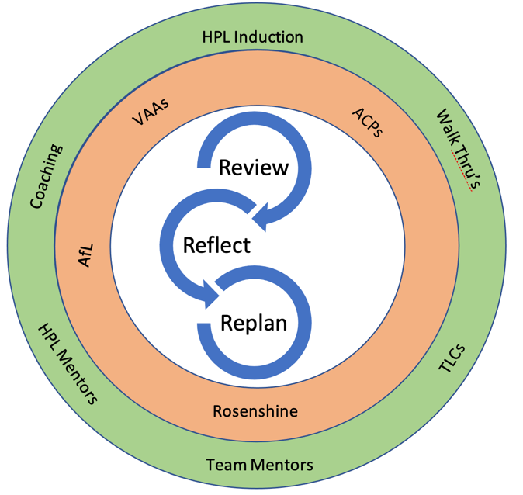
After the lesson the teacher will:
- Review how effectively children learned
• Use formative assessment, compare with previous cohorts, discuss with subject experts
- Reflect on what they, the teacher, did and the effect it had on all the pupils and their performance
- Replan to improve pupils’ performance now they know the children better

